Additional Experiments Suggesting that Neutral Nickel is Soluble in Silicate Melts at Low Concentration. T. Prissel and R. O. Colson¹, ¹Department of Anthropology and Earth Science, Minnesota State University Moorhead, Moorhead MN 56563 colson@mnstate.edu.

Introduction: Metal nuggets are often observed in experiments run at low fO₂ in silicate systems[1, 2]. Whether these beads were in suspension during the experiment or formed by exsolution during the quench remains unclear [3, 4] and has significant implications for petrogenesis at low fO₂ such as formation of lunar glass beads or separation of Earth' s core. We have performed two experimental tests to determine whether neutral Ni is in solution prior to quench or present as sub-micron sized nuggets in suspension: 1) If Ni⁰ is present in solution prior to quench, then quench rate should affect nugget size and density and 2) if nuggets form due to exsolution during quench then the solubility of the metal must increase with increasing temperature. Results are consistent with zero valence Ni forming by exsolution although several experimental complexities remain unexplained.

Experimental Methods: Experimental compositions were made by mixing reagent grade oxides to yield 57.5wt% SiO₂, 7.2%Al₂O₃, 31.3%MgO, and 4%CaO (CaO added as CaCO₃). Ni was added as 0.01” diameter metal wire kept in a desiccator to minimize oxidation (no NiO was added to the experiments). Experiments were run in a 1-atm gas mixing furnace at ~1625ºC. A Type-S thermocouple was used to measure the temperature in the furnace prior to experiments (the TC was not left in the furnace during low fO₂ experiments to avoid C contamination to the TC). Experiments were run at low fO₂ (in graphite capsules with a CO-atm) to prevent oxidation of Ni and ensure the concentration of NiO in the melt was well below detectable limits in order to examine Ni⁰ without the complexity of divalent Ni in the melt as well. Given our measured concentration of neutral nickel in the melt, the results apply to naturally-occuring fO₂.
Previous experiments [4] were run in graphite capsules in Pt wire cages. However, failure of the Pt in the CO-rich atm limited experimental duration to ~30min and temperatures ≤ 1550ºC. To allow for longer experiments and higher temperatures, we placed the graphite capsule in an Alumina tube. Eight holes were drilled in this tube, four around the base, and four ~20cm above the base to facilitate flow of CO through the tube.
To test for any dependence of Ni nugget size and density on the rate of cooling, two different quench rates were used. VesNiWire#6, the fast quecnh experiment, was pulled out of the furnace and dumped directly into a water bath. The resultant quench rate was about 90ºC/sec. VesNiWire#7b, the slow quench experiment, was removed from the furnace and let sit inside the alumina tube on a cooling rack with a cooling rate of about 8ºC/sec (average cooling rate estimated by how long it took the graphite capsule to stop glowing).
Ni metal was removed from the silicate glass prior to mounting samples in epoxy in preparation for Electron Microprobe Analysis (EMP) and mapping by Backscattered Electron Imaging (BEI). Separating the metal from the glass was done to prevent the presence of Ni metal from corrupting EMP analyses of low-concentration Ni in the glass
Nugget density was determined by dividing the sample into quadrants, imaging by BEI (at 1000x and 3000x), and examining each image for Ni nuggets (appearing as bright spots in BEI). Ni nuggets were counted in each of the images and the density of Ni nuggets calculated.
Size of the Ni nuggets, which were smaller than the resolution of the BEI, was calculated by analyzing a 10µm diameter spot which included the nugget and calculating an effective size of the Ni metal bead that would account for the observed concentration of Ni (if significant Ni was observed in the surrounding glass this calculation was modified accordingly).
EMP analyses were also done on the glass where no visible Ni nuggets were found. These analyses were done in various areas of the glass bead and concentration profiles were determined going away from the metal/glass interface.

Experimental Results: If Ni⁰ is in solution prior to quench then quench rate should affect the size and number of beads (with higher quench rates resulting in more and smaller beads). If Ni⁰ exsolves during the quench then its solubility must necessarily decrease with T and higher T experiments should contain more Nickel.
We observe a correlation between nugget size and quench rate for our experiments at ~1625ºC (Fig. 1), similar to the results of [4] at ~1550ºC. Bead size is generally larger in the slower quench experiments, consistent with Ni⁰ being dissolved in the melt prior to quench. Also the density of beads is higher in the faster quench experiments (Fig. 2), again, suggesting that Ni nuggets may represent soluble Ni⁰ that exsolves during the quench.
Another important find was that even though nugget size and density both change due to quench rates, the total apparent concentration of Ni near the metal interface (combining microprobe analyses of the glass with Ni present as beads) stays roughly the same (Fig. 3). This again suggests that neutral Ni is indeed soluble in the silicate melt since there is no reason to expect the concentration of Ni in suspension to be the same for the two experiments, particularly since the concentration of observable metal nuggets is so different.
If neutral Ni is soluble in the melt during equilibrium as suggested by [3, 5], we should see the concentration of Ni in the silicate melt increase as Temperature increases (otherwise the nuggets wouldn't form during the quench). We see this in (Fig.4), again, supporting the idea that Ni⁰ is dissolved in the silicate melt at equilibrium and doesn’t represent nuggets “stirred” into the melt.

Experimental Complexities: Although our specific tests cited above provide strong support for neutral Ni being soluble in silicate melt, many experimental observations raise questions that remain unanswered, and require further experimentation. For example:
- A heterogeneous distribution of Ni nuggets was found in both experiments (e.g. density observed for the bottom of the sample of VesNiWire#6 was 3-to-7 times higher than other locations.)
- In all experiments the larger nuggets were found in the middle of the sample.
- Fewer Ni beads were observed near the metal-melt interface compared to the interior of the sample.
- Fewer/smaller beads were found near the gas/melt interface than either the interior of the sample or near the metal/melt interface.
- A steep Ni concentration gradient was observed in the glass in the 80µm near the metal interface, with concentrations decreasing sharply away from the metal interface (reported also in [4, 6] and interpreted as due to significant volatile loss of Ni).
- A black film, presumably C, coated the glass bead in VesNiWire#6 after it’s more rapid quench and was observed in patches in VesNiWire#2. It was not found on VesNiWire#7b.
- Vesicles were observed throughout the samples, often in the interior of the bead (suggesting formation during quench) and at the metal/melt interface. Vesicles ranged in size from a few microns in diameter to many tens of microns. The number of vesicles was 10x higher in the slower-quenched experiment. Vesicles were also observed in the metal phase.

Conclusion: We confirm that the concentration of Ni⁰ in the silicate melt increases with temperature, as expected if nuggets form during the quench . Ni nugget size and density depend on quench rate while the total concentration of Ni in the sample remains roughly the same. These observations are consistent with a low, but measurable, amount of Ni⁰ dissolved in the silicate melt and have implications for a number of petrologic problems at low fO₂, such as early core formation and volcanism on the moon.

References: [1] Borisov A and Walker R J (2000), Am Mineral. 85, 912-917, [2] Brenan J M, McDonough W F, and Ash R (2005), Earth Planet. Sci. Let. 237, 855-872, [3] Cottrell E A and Walker D (2006), Geochim. et Cosmochim Acta, 70, 1565-1580, [4] Nesheim T, Colson R. O. Cota, A., Larson, A. Rock, J and Johnson C (2007), LPSC XXXIIX, 1719, [5] Colson, R. O. (1992), Nature 357, 65-68, 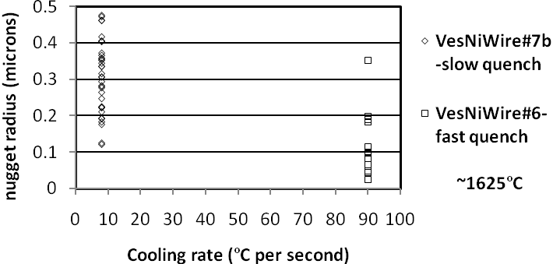
Fig 1. Average size of Ni nuggets is significantly smaller in the faster quenched experiment.

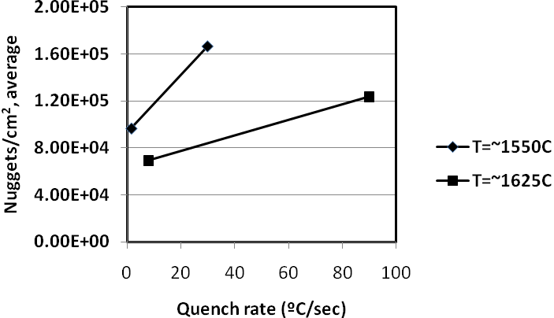
Fig 2. Number of Ni nuggets per unit area is higher in the faster-quenched experiments (1550ºC data from [4]).

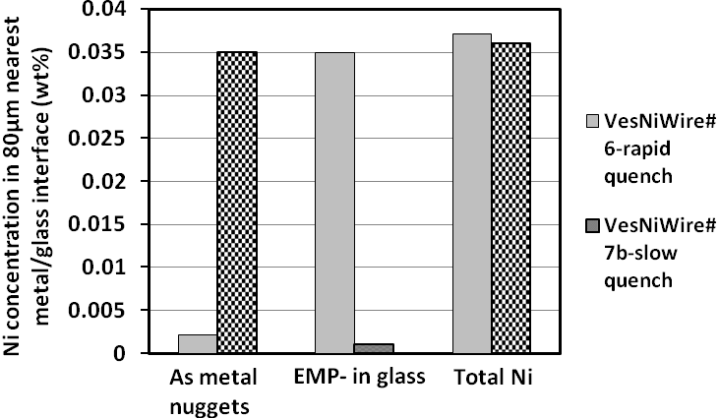
Fig 3. Despite the large variation in observed size and density of Ni nuggets with quench rate, the total concentration on Ni (from both nuggets and EMP analyses in areas where no nuggets are observed) is roughly constant with quench rate, as also observed by [3, 4].

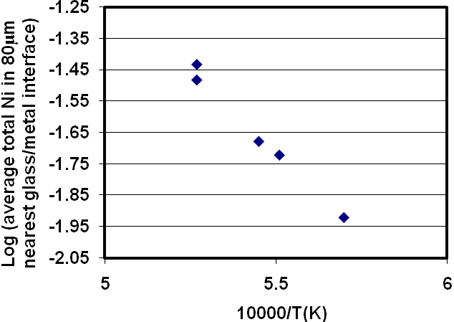
Fig 4. Observed total concentration of Ni near the metal/melt interface increases with increasing T, as also reported by [5]. Values at about 1550ºC are from [4]).

