REINTERPRETATION OF OBSERVED EFFECTS OF CO ON CRYSTALIZATION IN SILCATE MELTS AT 1-ATMOSPHERE PRESSURE. A. L. Larson, R. O. Colson¹, and E. Hay. ¹Minnesota State University Moorhead, Moorhead MN 56563, colson@mnstate.edu.

Introduction: Last year we reported an unexpected influence of CO on crystallization of olivine in some silicate melts, interpretting an apparent increase in the liquidus temperature of one hundred degrees Celsius. New experiments show that at least some of the effect of CO is to cause a reproducible increase in quench crystal growth rather than a change in liquidus temperature. While this is more easily understood than a 100ºC change in the liquidus temperature, it still suggests an unexpected effect of CO on silicate melts at 1-atmosphere pressure, and the possibility that CO is soluble in silicate melts even at low pressure (at least in some compositions).

Methods: Experimental compositions (Table 1) were made from reagent grade oxides and CaCO₃. Water loss was determined by previous drying and weighing and was incorporated into the measured reagents. Compositions were ground under methanol with mortar and pestle for a minimum of twenty minutes for homogeneity.
The compositions were formed into a pellet, mounted on a platinum loop, and melted to make a glass bead. Experiments were done in a one-atmosphere gas mixing furnace. Temperature was measured with a type-S Pt-Rh thermocouple. Levels of CO and CO₂ were controlled with needle-valve gas flow meters.
Samples were equilibrated for 45 minutes to 48 hours. They were then air quenched and examined under a dissecting microscope.
In previous experiments [1], samples were air quenched and examined optically under a microscope for olivine crystals in an effort to constrain the liquidus temperature. Because the samples were Fe-free, even very small crystals were easily seen.
Some of the Experiments of the present study were drop-quenched into a beaker of cold water by using electrical current to melt 0.01” diameter Pt attachment wires. The bottom of the furnace was opened for the drop only three seconds before the current was applied.
Results: Previous results [1] showed that presence of CO gas affects the temperature at which crystals appear in the melt. We have confirmed this effect in new air-quench experiments; significantly more crystals form in a CO-rich atm than in CO₂ in composition 1, and crystals occur at higher temperature.
Experiments in an expanded suite of compositions show greater ambiguity; the strong effect of CO on the apparent liquidus is not seen for all compositions, occuring only in melts with higher expected liquidus temperatures (Table 2). In addition, the extent of crystallization and morphology of crystals above the expected liquidus temperature for two compositions (5&7) raised the likelihood that crystal growth was occurring during air-quench.
Drop quenching experiments in compositions 5 & 7 reduced or eliminated crystals above the expected liquidus temperature, confirming this. For example, a drop quench with composition 7 resulted in no crystals at 1537°C, well below where extensive crystallization was seen in air quench experiments.
Previously [1], we thought crystals in composition 1 represented equilibrium growth prior to quench for three reasons: 1) Experiments were carefully reversed, 2) There was a consistent trend in apparent liquidus with increasing CO concentration, and 3) Crystals were not obviously dendritic or skeletal. Drop quench experiments were done with composition 1 to see if quench crystallization occurred for that composition. In experiments in CO-rich atmospheres, crystals form in air quenched experiments well above the expected liquidus temperature. These crystals were not observed in experiments drop-quenched into water (absence of crystals was noted visually under a microscope and confirmed with powder XRD), confirming that at least some of the crystal growth reported in CO occurs during the quench. Other observations consistent with quench growth include the white appearance of the crystals, their common dogtooth appearance (see Figure 1), and the fact that in composition 1, the crystals only grow from the platinum wire, which possibly acts as a nucleation site for quench crystal growth. Less indicative of quench growth is the observation that in composition 2 in CO-rich atmosphere, clear, euhedral crystals, not associated with the Pt wire, were observed at temperatures well above the presumed liquidus (in addition to dogtooth white crystals along the Pt wire). We are currently examining whether these euhedral crystals in composition 2 still occur in drop-quenched experiments.
Discussion: We have reproduced the effect of CO on crystal formation in the compositions reported previously (compositions 1 and 2), but results are more complex in new compositions (Tables 1 and 2). At least some of the crystals observed are due to quench growth, suggesting that CO affects the quenchability of some melts. This might be due to an effect on crystal nuclei in the melt, changes in melt fluidity, or an effect on the suitability of Pt as a nucleation site.
We confirm the observation of significantly greater quench crystal growth in composition 1 when run in a CO-rich atmosphere, which may suggest that CO is sufficiently soluble in the melt to affect melt properties. CO has been observed to be soluble in some compositions [2], but not others [3]. CH₄, have been observed to increase the olivine stability field [4], consistent with depolymerization of the melt, which could enhance quench crystal growth--perhaps CO acts similarly. However, these previous studies were done at elevated pressure and it’s unclear why or how CO might influence crystal growth at low pressure.
Conclusion: We observe an effect of CO on crystal growth in silicate melts similar to [1], but conclude that at least some of the observed effect is related to changes in quenchability. CO may affect melt fluidity (allowing greater quench growth rate), durability of nuclei at higher temperatures, or it may enhance the effectiveness of platinum wire as a nucleation site. If CO at 1-atm affects the behavior of silicate melts, this is potentially important in lunar magmatic systems and is an observation worth pursuing further.

Table 1-Nominal compositions
 |  | SiO2 | Al2O3 | MgO | CaO
Comp. 1 | PtlpSCMA- 7-1 | 57.5 | 7.2 | 31.3 | 4
Comp. 2 | PtlpSCMA- 10-2 | 52.7 | 10 | 35.3 | 2
Comp. 3 | PtlpSCMA- 10-3 | 50 | 10 | 21.1 | 18.8
Comp. 4 | PtlpSCMA- 10-4 | 46.7 | 10 | 28.2 | 15.1
Comp. 5 | PtlpSCMA- 10-5 | 43.9 | 10 | 36.1 | 10
Comp. 6 | PtlpSCMA- 10-6 | 60 | 10 | 27.3 | 2.7
Comp. 7 | PtlpSCMA- 0-7 | 62.9 | 0 | 32.1 | 5
Comp. 8 | Ni-gg17Mg | 55.8 | 9.4 | 16.5 | 18.6

Table 2-Expected and Apparent Liquidus
 |  | Expected Liquidus T | Apperent Liquidus T measured in CO2 | Apparent Liquidus T measured in CO-rich atm.
Comp. 1 | PtlpSCMA- 7-1 | ~1515 | 1503-1514 | 1619-1630 (90% CO)
Comp. 2 | PtlpSCMA- 10-2 | ~1575 | 1570-1580 | 1639-1647 (50% CO)
Comp. 3 | PtlpSCMA- 10-3 | ~1400 | 1430-1435 | 1430-1445 (90%CO)
Comp. 4 | PtlpSCMA- 10-4 | ~1500 | 1581-1589 | 1511-1524 (90% CO)
Comp. 5 | PtlpSCMA- 10-5 | ~1600 | >1657 | >1569 (90% CO)
Comp. 6 | PtlpSCMA- 10-6 | ~1440 | 1455-1466 | 1456-1462 (90% CO)
Comp. 7 | PtlpSCMA- 0-7 | ~1540 | >1582
Comp. 8 | Ni-gg17Mg | ~1345 | 1314-1324 | 1314-1324 (75% CO)

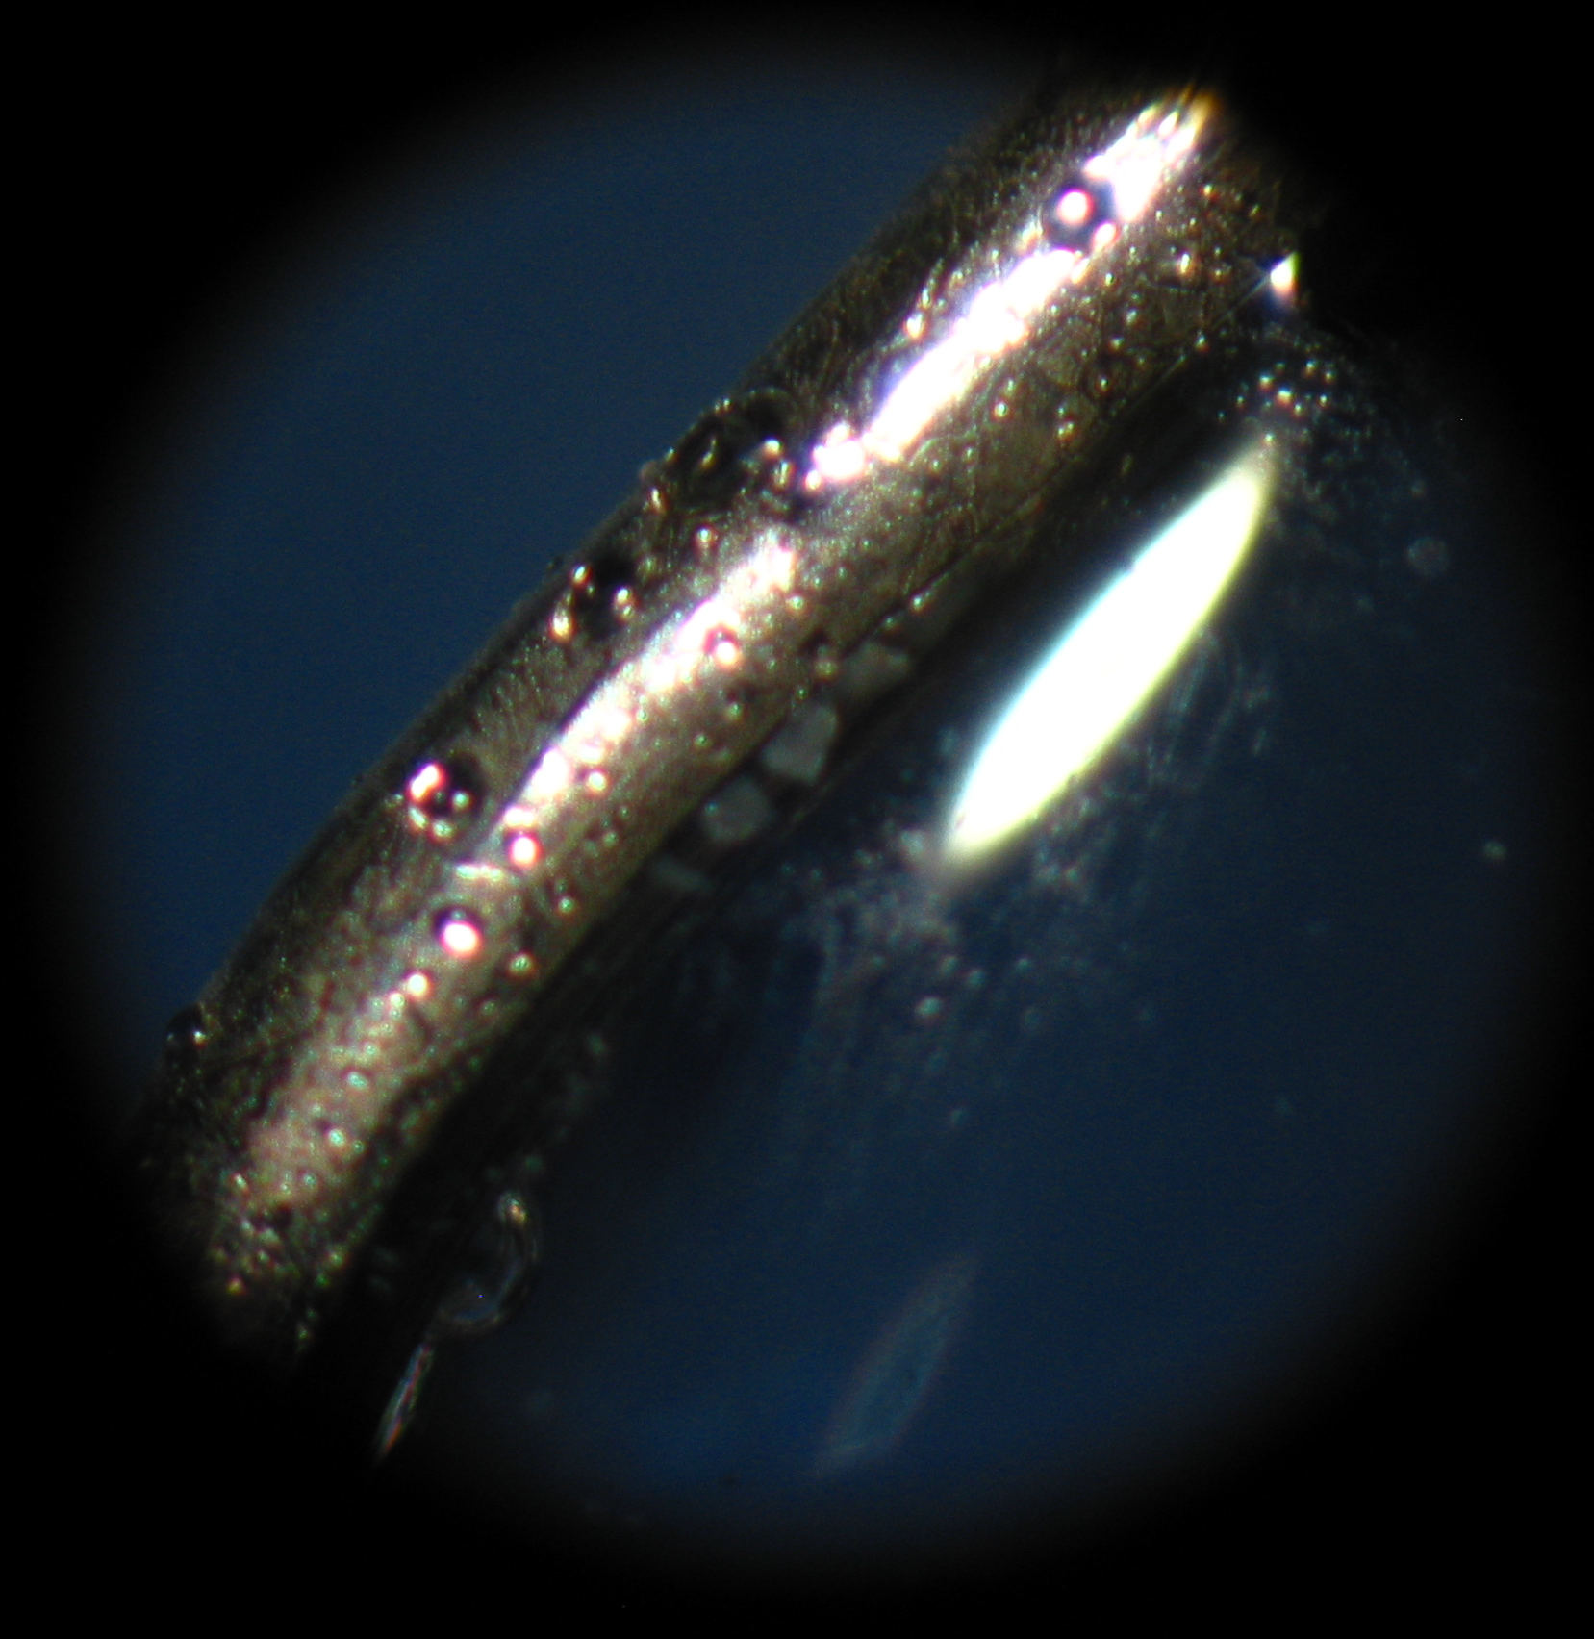
Fig. 1. Small patch of dog-tooth crystals along Pt loop in an experiment run in CO₂ and air quenched. Siginificantly more crystals are observed along the Pt wire when experiments are run in CO at the same temperature.

References: [1] R. O. Colson, E. Hay, A. Larson, and A. Cota (2008) LPSC XXXIX, 1310. [2] Eggler et al. 1979. Earth & Planetary Science Letters. 43,321-330. [3] Pawley A. R., Holloway J.R., and McMillan P. F. (1992) Earth Planet Sci Lett 110, 213-225. [4] Eggler D. H., and Baker D. R. (1982) Adv. Earth Planet Sci 12, 237-250.

